**Assignment sheet for IAM Assignment**

Name :Abhijit Barik Gmail id: abro45172018@gmail.com

1 :- Create an IAM user with username of your own wish and grant administrator policy

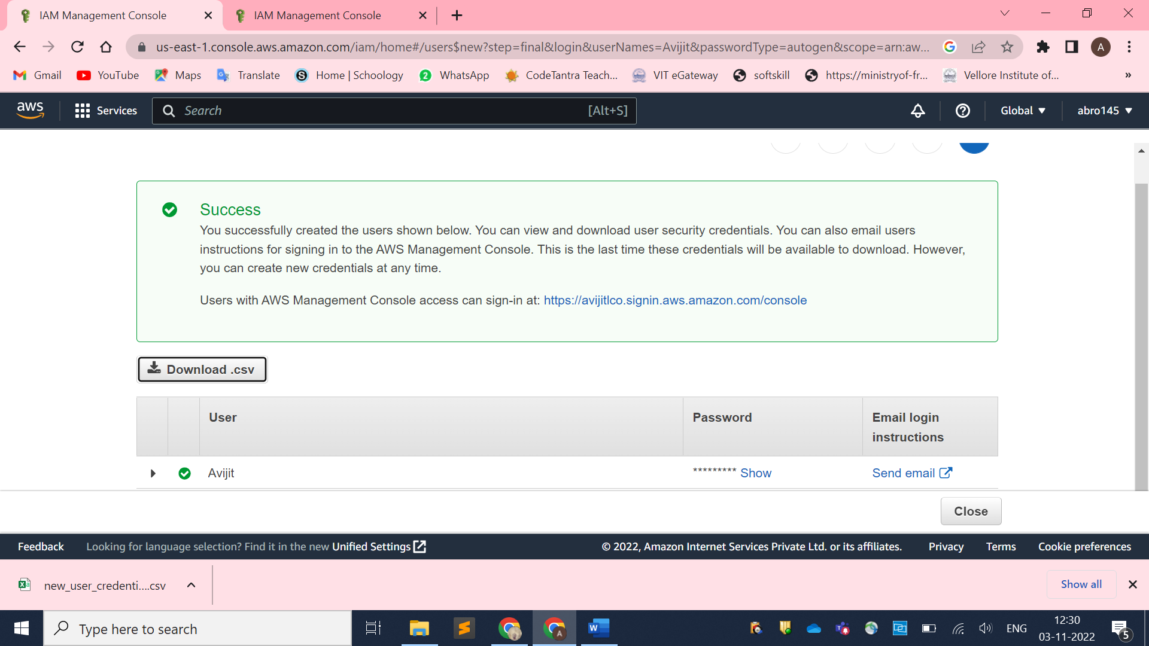

Assignment 2 :- Hello students, in this assignment you need to prepare a developers team of avengers. - Create 3 IAM users of avengers and assign them in developer’s groups with IAM policy

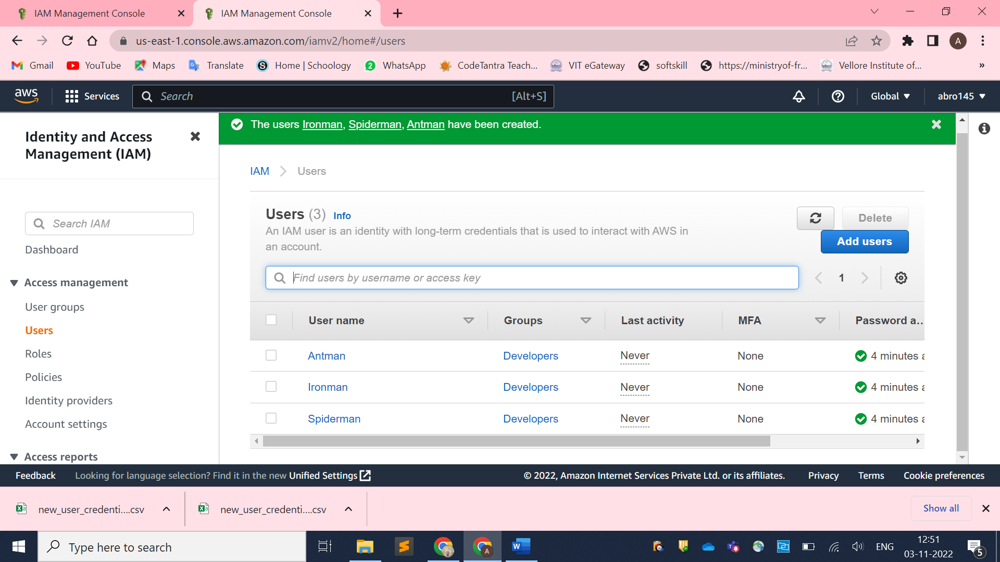

Assignment 3 :- Define a condition in policy for expiration like

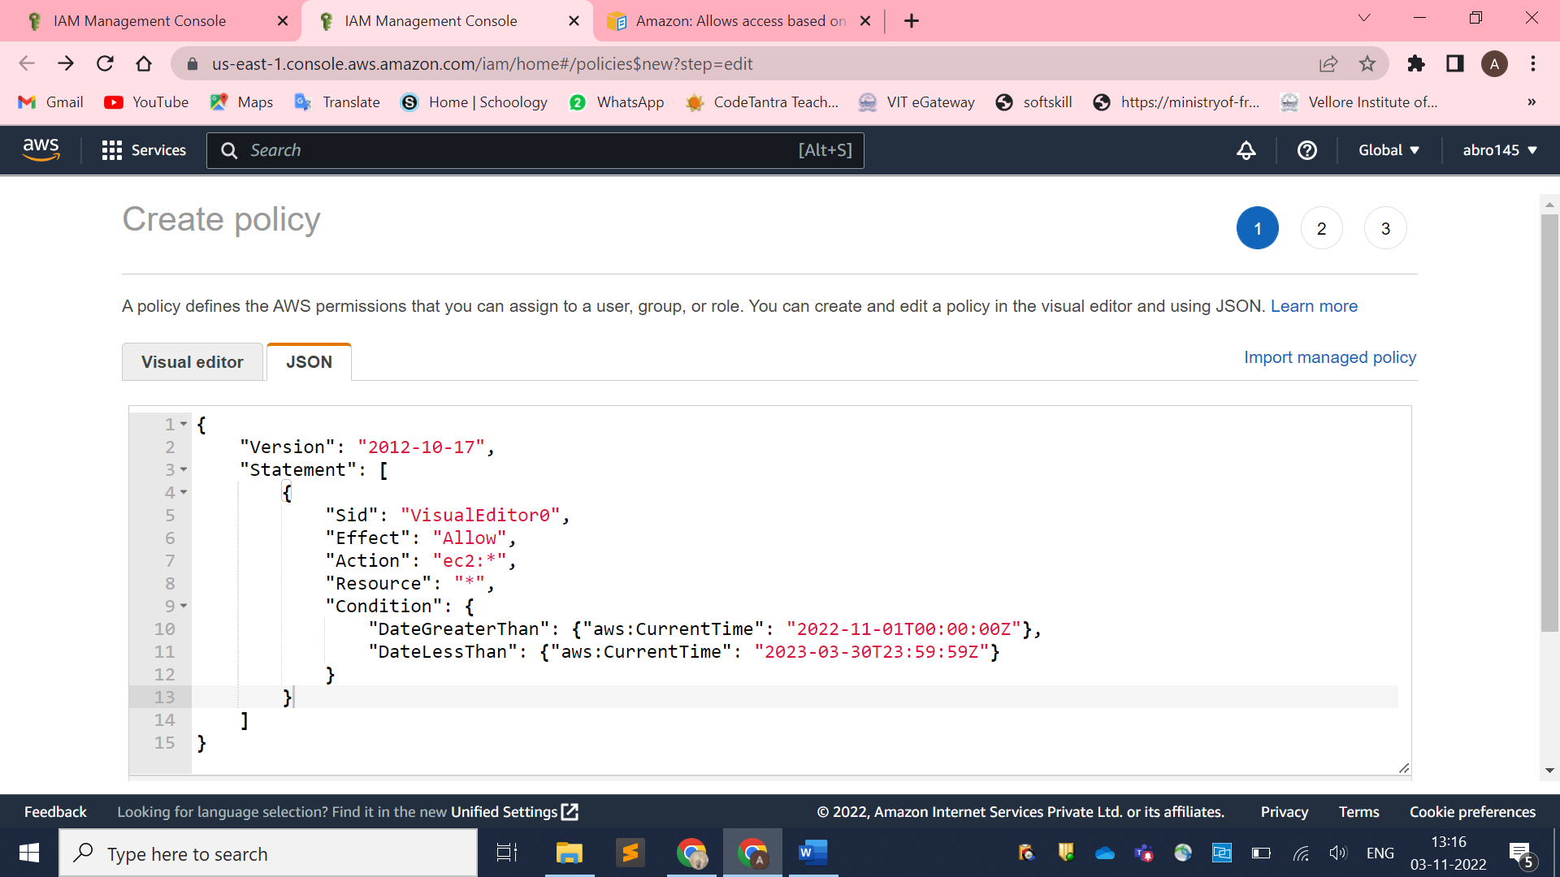

{

"Version": "2012-10-17",

"Statement": [

{

"Sid": "VisualEditor0",

"Effect": "Allow",

"Action": "ec2:*",

"Resource": "*",

"Condition": {

"DateGreaterThan": {"aws:CurrentTime": "2022-11-01T00:00:00Z"},

"DateLessThan": {"aws:CurrentTime": "2023-03-30T23:59:59Z"}

}

}

]

}

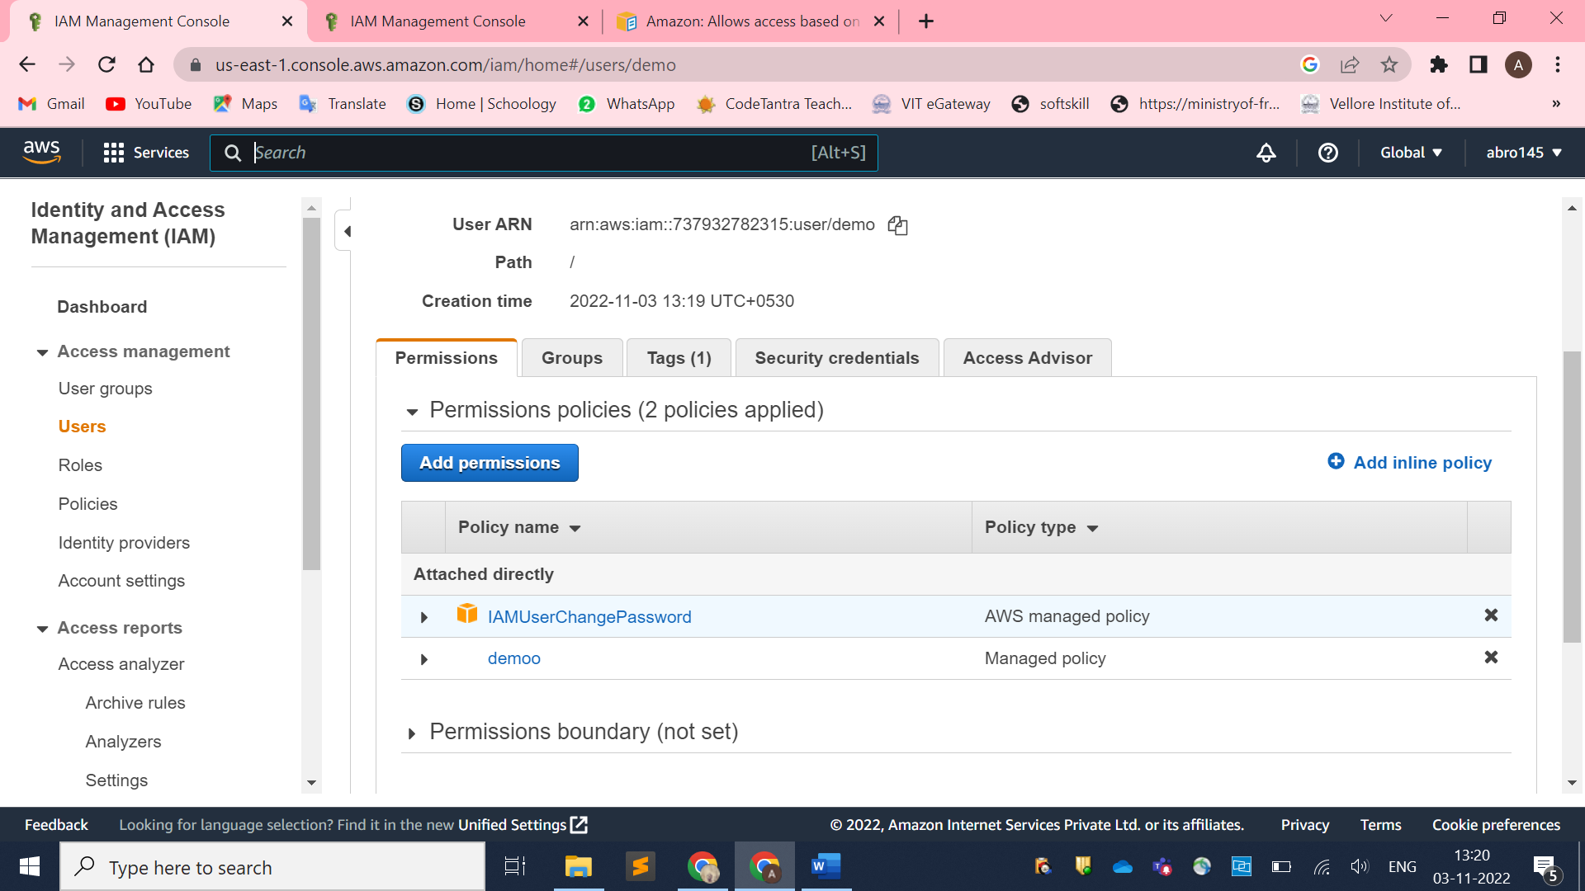

Assignment 3 :- Prepare 15 authentic MCQ questions related to IAM

**Which of the following is the most secure way of giving access to AWS services to applications running on Ec2 instances?**

answer choices

Creating Service users

Creating service groups

Roles

Q.

**True or False : An explicit Deny in IAM precedes over an explicit allow**

answer choices

TRUE

FALSE

Q.

**TRUE or FALSE : By default a new user in IAM has permisiions to log in to the AWS Console.**

answer choices

TRUE

FLASE

Q.

**Which of the following is not an IAM best practice?**

answer choices

Delete user accounts not in use

Attach policies to individual users

Manage permissions by adding users to groups

Q.

**Wch of the following set of credentials are used to log in to AWS programmatically? (Choose two)**

answer choices

Username

Access Key

Password

Secret Key

**Identify the wrong statement.**

|  |  |
| --- | --- |
| (a) | Identity and access management (IAM) is a framework for business processes that facilitates the management of electronic or digital identities |
| (b) | With IAM technologies, IT managers can control user access to critical information within their organizations |
| (c) | Identity and access management products offer role-based access control |
| (d) | In IAM roles are defined according to the ability of an individual user to perform a specific task, such as view, create or modify a file |

Show Answer

**Which of these is Identity in IAM?**

|  |  |
| --- | --- |
| (a) | Users |
| (b) | Groups |
| (c) | Roles |
| (d) | All of these  **An IAM user:**   |  |  | | --- | --- | | (a) | is an entity that you create in AWS | | (b) | is to give people the ability to sign in to the AWS Management Console for interactive tasks and to make programmatic requests to AWS services using the API or CLI | | (c) | A and B both | | (d) | None of these | | **IAM role:**   |  |  | | --- | --- | | (a) | Have credentials (password or access keys) associated with it | | (b) | Does not have any credentials (password or access keys) associated with it | | (c) | May or may not have credentials (password or access keys) associated with it | | (d) | None of these | | | |  | |  | | |  |  |  |  |  |  |  |  |  |  |  |  |  |  |  |  |  |  |  |  |  | | --- | --- | --- | --- | --- | --- | --- | --- | --- | --- | --- | --- | --- | --- | --- | --- | --- | --- | --- | --- | --- | | **AWS evaluates _______ when an IAM principal makes a request.**   |  |  | | --- | --- | | (a) | Username and Password | | (b) | MAC Address | | (c) | Security Policies | | (d) | IP Address  **AWS supports ______ types of policies.**   |  |  | | --- | --- | | (a) | 4 | | (b) | 5 | | (c) | 6 | | (d) | 7 | |  |  | |  |  | | | | | **Answer:**  Option **(b)** | |

|  |  |  |  |  |  |  |  |  |
| --- | --- | --- | --- | --- | --- | --- | --- | --- |
| **How many maximum groups can be created in an AWS account?**   |  |  | | --- | --- | | (a) | 25 | | (b) | 50 | | (c) | 100 | | (d) | 200 | |
|  |  |
| **How many maximum access keys can be assigned to an IAM user?**   |  |  | | --- | --- | | (a) | 1 | | (b) | 2 | | (c) | 3 | | (d) | 4 | | **Answer:**  Option **(c)** |

Assignment 4 :- Launch your linux instance in IAM and update your machine.

